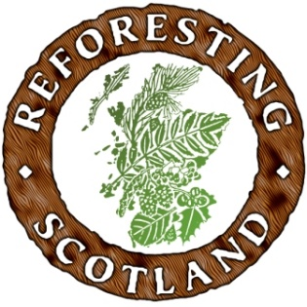
Scotland’s Land Revival- A Tour through the New Landscapes of Woodlands and their Communities
This summer & autumn, 30 young professionals will be visiting 3 clusters of sites in different parts of Scotland. They will come from a wide variety of organisations with an interest in how Scotland’s land is used. They will spend the two days experiencing, listening and debating the future of Scotland’s land use.
Joining them will be local experts, students and the media. TV, radio, video and written articles will be produced and disseminated widely. Millions of people around Scotland and beyond will hear about this Land Revival tour and think afresh about Scotland’s landscapes.
We would like you to join us.
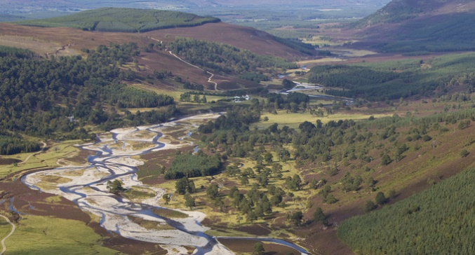
June we will be in the northern Cairngorms visiting a large ecological restoration site at Glen Feshie plus smaller scale community projects which work with the local forest.
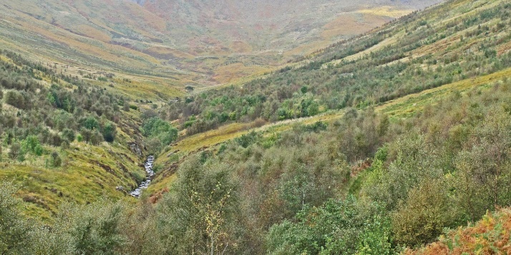
August will find us in southern Scotland around the Moffat area, visiting the impressive Wildwood project, riparian woodland restoration, foraging and the use of biomass.
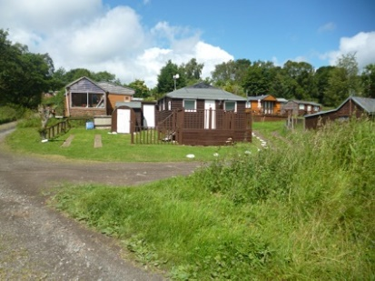
October will be in north central Scotland, around Kilsyth, looking at land reclamation through reforestation, hutting and building resilient communities through green networks.
Healthy Communities in a Well Forested Land
Not all land use in Scotland is perfect- far from it. But there are glimpses of better things happening. The question is how to link projects together and encourage more to develop.
What’s in it for you?
You will be inspired by what you see and by the people who are doing it on the ground. You will be giving your own perspectives and listening to others, building up a picture of how Scotland could be in the future. You will be sharing your insights with the group and with a much larger audience through the media. You will be developing professionally. You will remember these visits throughout your career.

Contact Donald McPhillimy, Reforesting Scotland donaldmcphillimy4@gmail.com

