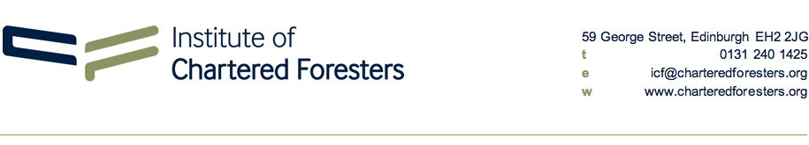
PME1: Professional Membership Entry Registration Form
Expected Submission Date: |  |  |  | (DD/MM/YYYY)
Personal Details
Name:
Membership No: |  |  |  | Date of Birth:
Home Address: |  |  |  | Work Address:
County: |  |  |  | County:
Postcode: |  |  |  | Postcode:
Personal Mobile: |  |  |  | Work Phone:
Personal Email: |  |  |  | Work Email:
 |  |  |  |  | Delete as appropriate
Nationality: |  |  |  |  | UK National / EU National / International
Would you like us to contact you about PME at work or home? |  |  |  |  | Work / Home
Preferred designation (if promoted to Professional Membership): |  |  |  |  | Chartered Forester / Arboriculturist
It is the intention of the Institute to seek to accommodate any legitimate special needs of any applicant whenever and wherever possible. The Institute will endeavour to make all reasonable adjustments to the Professional Membership Entry process if informed by the applicant in advance of a submission. Please use the box below to inform the Institute of any specific learning differences (SpLD). This information will be treated in the strictest confidence.
Verifier’s Details. This section must be completed and signed by your Verifier. (See PME Guidance Notes for further information).
Verifier’s Name:
Position
Employer:
Work Address:
Postcode:
Telephone:
Email:
Relationship to applicant:
I verify that the details given here are correct to the best of my knowledge and agree to act as a Verifier for this applicant’s PME submission as outlined in the guidance provided. I understand that the Institute of Chartered Foresters may seek further information from me in support of this application.
Verifier’s Signature: |  |  |  |  |  | Date:
Your Data
The Institute will hold and use your data in compliance with the General Data Protection Regulations and with the Data Protection Act 1998 to perform our services in relation to your membership and participation in these assessments. The Institute will treat all information contained within this form as confidential and use it only for those purposes expressed. It will not be divulged to other parties. Click here to view the Institute’s privacy policy.
Applicant’s Declaration and Signature:
I certify that the information contained within and attached to this form is true and accurate to the best of my knowledge and belief. I understand that any information that is knowingly withheld, suppressed, deliberately misleading or false may make me liable, if elected as a Member of the Institute of Chartered Foresters, to dismissal from the Institute. If promoted to Professional Membership, I agree to comply with the Royal Charter, Bylaws and Regulations of the Institute of Chartered Foresters and with any subsequent amendments and/or alterations that may be made to them.
Applicant’s Signature: |  |  |  |  |  | Date:
Form Submission & Payment for Assessment Fees
The 2024 PME assessment fee is £475.00, payable in two instalments: £225.00 with your registration form by 1 June and £250.00 when you submit your completed written assessment by 1 August.
Please select (X) your preferred method of payment for your examination fees:
 | BACS: email your form to icf@charteredforesters.org (we will send you an invoice for your fees)
 | Credit / Debit Card: email your form to icf@charteredforesters.org and call 0131 240 1425 to pay

